Dependent variables: Wing length, Adult mass, Pupae mass

Independent variables: Emergence Date, Original densities, Per capita mortality, Predator Density, DOC, Pond Temp

X = need to get from Lauren

|  |  |  |  |  |  |  |  |  |  |  |  |  |
| --- | --- | --- | --- | --- | --- | --- | --- | --- | --- | --- | --- | --- |
|  | **Site** | **Year** | **SampDate1** | **EmerDate** | **LnImmatureslitersampdate1** | **percapitamort** | **lnBeetleliter** | **DOCmean** | **Temp** | **Pupaemass** | **Winglength** | **AdultMass** |
| 1 | Black | 2011 | 5/24/2011 | 6/16/2011 | 3.518024 | 0.103642 | 0.156764 |  | 9.182805 | 1.491217 | X |  |
| 2 | Black | 2012 | 5/8/2012 | 5/28/2012 | 2.98366 | 0.102479 | 0.073361 |  | 8.131086 | X | X |  |
| 3 | Dispersal pond | 2017 | 6/1/2017 |  | 2.63135 |  |  |  |  |  |  |  |
| 4 | East | 2011 | 5/24/2011 | 6/14/2011 | 2.618207 | 0.092285 | 0.122652 |  | 8.692377 | 1.200521 | X |  |
| 5 | East | 2012 | 5/8/2012 | 6/2/2012 | 0.749224 | 0.009937 | 0.031379 |  | 5.744982 | X | X |  |
| 6 | East | 2017 | 5/17/2017 | 6/11/2017 | 1.960963 | 0.048679 | 0.093709 | 44.25222 |  | 1.007917 | 9.216667 | 0.626667 |
| 7 | Experiment | 2017 |  | 6/10/2017 |  |  |  | 43.12333 | 7.993333 |  |  |  |
| 8 | Ice | 2011 | 5/24/2011 | 6/14/2011 | 0.747813 | 0.021315 | 0.391959 |  | 7.796733 | X | X |  |
| 9 | Ice | 2012 | 5/8/2012 | 6/4/2012 | 0.226038 | 0.006741 | 0.268979 |  | 8.330678 | X | X |  |
| 10 | Ice | 2017 | 5/17/2017 | 6/7/2017 | 1.305336 | 0.056401 | 0.380261 | 26.32833 | 9.302733 | 1.64125 | 10.70417 | 1.7 |
| 11 | JuncusTown | 2017 | 5/19/2017 | 5/28/2017 | 0.852295 | 0.027673 | 0 | 23.37333 |  | 0.93625 | 8.925 | 0.692083 |
| 12 | Mozvalley | 2017 | 5/23/2017 | 6/6/2017 | 3.090713 | 0.07288 | 0.159655 | 46.01833 |  | 1.097857 | 9.770833 |  |
| 13 | NoOil | 2017 | 5/19/2017 | 5/29/2017 | 2.811124 | 0.017147 | 0.135381 | 45.39667 |  |  | 8.625 |  |
| 14 | Oil | 2017 | 5/17/2017 | 5/30/2017 | 1.706055 | 0.038097 | 0.038403 | 38.69167 | 9.668328 | 1.373913 | 10.14167 |  |
| 15 | SBS | 2017 | 5/17/2017 | 6/3/2017 | 2.770484 | 0.209931 | 0.089347 | 24.73667 |  | 1.2076 | 9.741667 | 0.867083 |
| 16 | SeahorseWetland | 2017 | 5/23/2017 | 6/10/2017 | 1.082251 | -0.01185 | 0.191103 | 24.79 |  | 1.0424 | 9.7875 | 0.8275 |
| 17 | ShotgunFairy | 2017 | 5/17/2017 | 6/1/2017 | 0.842335 | 0.039348 | 0.030132 | 57.89556 |  |  |  |  |
| 18 | Target | 2017 | 5/17/2017 | 6/5/2017 | 1.22422 |  |  | 48.79667 |  | 1.577857 | 10.32917 |  |
| 19 | Vulgaris | 2011 | 5/24/2011 | 6/12/2011 | 2.998785 | 0.051029 | 0.354727 |  | 7.849901 |  |  |  |
| 20 | Vulgaris | 2012 | 5/8/2012 | 5/23/2012 | 2.629268 | 0.094259 | 0.147094 |  | 6.308046 |  |  |  |
| 21 | Vulgaris | 2017 | 5/17/2017 | 6/3/2017 | 2.907141 | 0.029061 | 0.214142 | 75.15 | 8.743286 | 1.084 | 9.491667 |  |
| 22 | Vulgaris road | 2017 | 5/20/2017 | 6/5/2017 | 2.390471 | 0.001207 | 0.295648 | 59.365 |  |  | 9.6625 | 0.971667 |
| 23 | Vulgaris small | 2017 | 5/20/2017 | 6/7/2017 | 1.659185 | 0.055534 | 0.167665 | 45.02833 |  |  | 10.12917 |  |
| 24 | Waterfall | 2017 | 6/4/2017 |  | 2.186229 |  |  |  |  |  |  |  |

Wing length and Adult mass power function

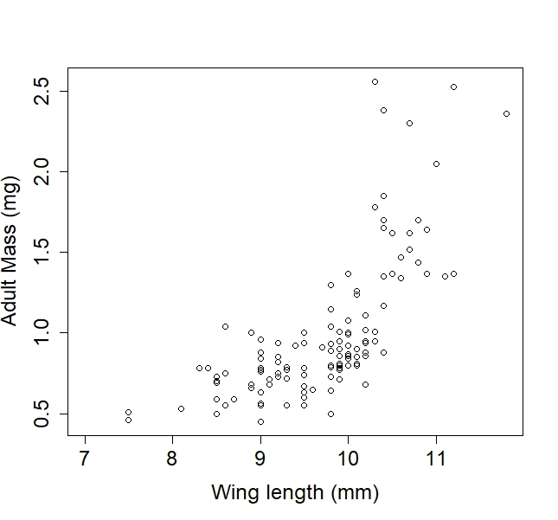

Average larval and pupal densities w/ SE from ponds. The last date is the last sampling date BEFORE moz started emerging. (**some issues w. dates)

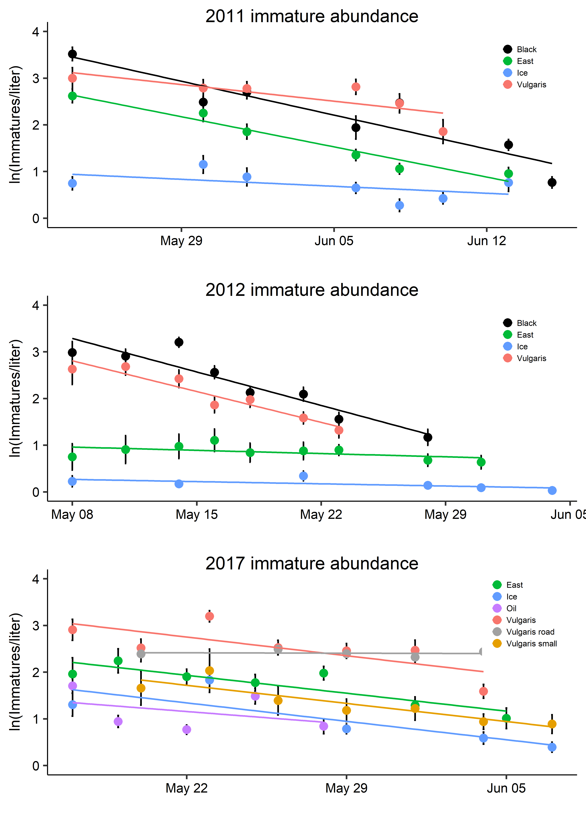

Each point is a pond from 2011, 2012 or 2017. Per capita mortality calculated as -1*slope of line in 1st figure. Plotted against the initial density/liter (from first sampling event of year). Positive slope (significant) indicates that there is negative density dependent mortality. Since there is increasing variance as N increases, try a quantile regression

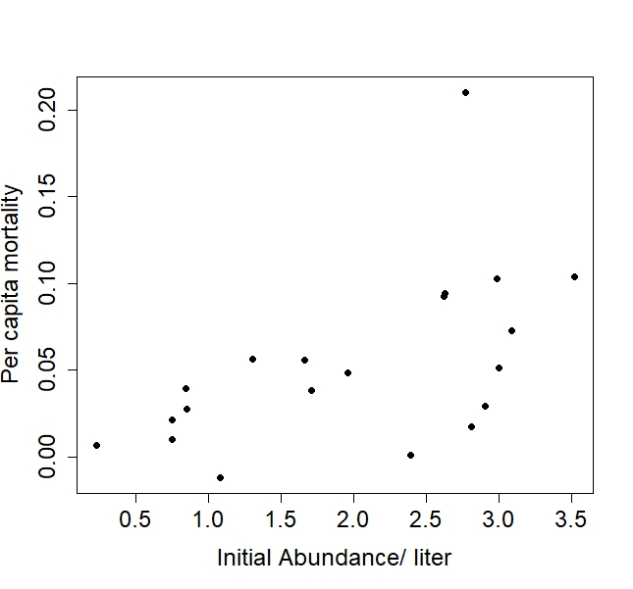 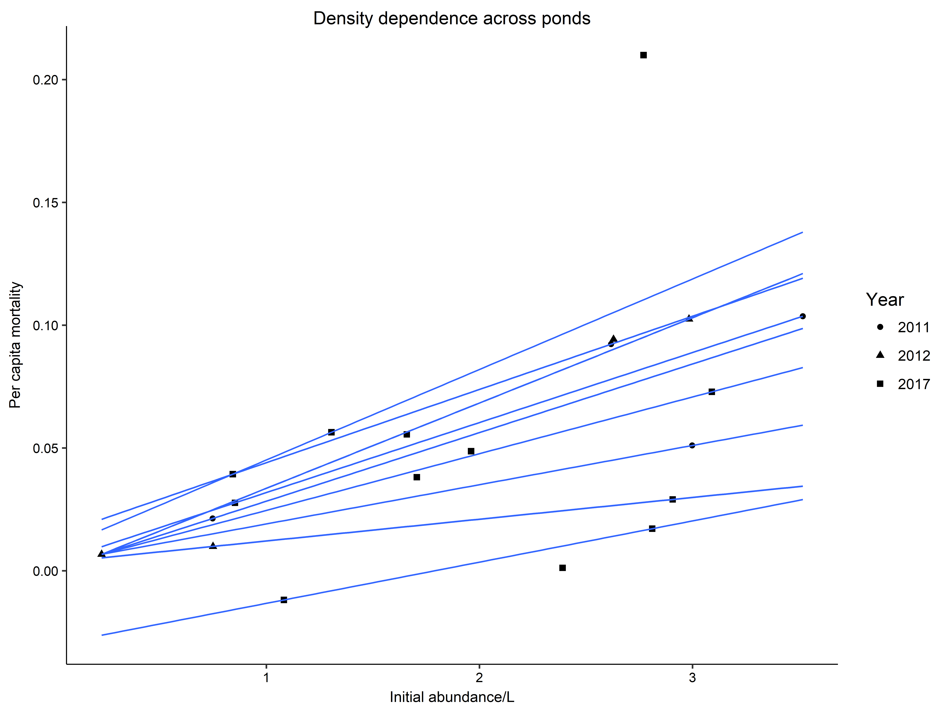

Coefficient estimates from the quantile regression

tau= 0.1 tau= 0.2 tau= 0.3 tau= 0.4 tau= 0.5 tau= 0.6 tau= 0.7 tau= 0.8 tau= 0.9

(Intercept) -0.03000431 0.003297362 0.003131091 0.001522726 0.000428211 0.003383606 -0.001106068 0.01423888 0.008324381

Larvaepupaeliter 0.01677310 0.008862323 0.015972306 0.023087756 0.027929919 0.028498385 0.034717610 0.02980900 0.036830541

Are residuals from linear model (per capita mortality ~ N) explained by food quality (DOC) or predator density (beetle abundance)?....Maybe a weak correlation with DOC (low DOC = higher mortality). No real relationship with beetle density

